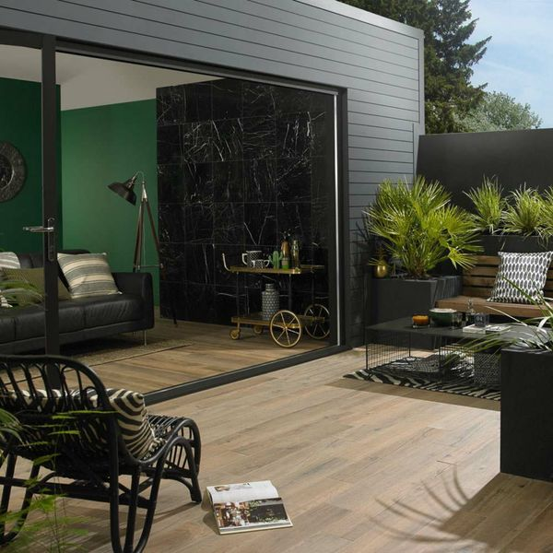**Muniellos Honey Oak:**

## **Product Description**

Alive with rustic knots and grains, these Honey Oak 90x15 Anti-Slip Tiles have a realistic wood effect design, so they're perfect for injecting the natural look into an interior area. They have an R11 anti-slip surface, with a matt finish, and they're made from durable porcelain so they are very hard-wearing! For a closer look, order a sample tile.

There are 33 different designs that are distributed randomly in each square metre to ensure a varied floor space.

## **Product Info**

* Product ID: 36539
* Tiles Per SQM: 7.4074074074074
* Sale by: Per SQM
* Size: 150x900x10mm
* Weight: 3.28 KG
* Material Type: Porcelain
* Finish: Matt
* Colour: Brown
* Suitability: Floors, Walls
* Area Of Usage: External
* Grade: 4
* Rectified Edge: Yes
* Underfloor Heating: Yes
* Anti Slip Grade: R11 / 35 Degrees
* Document: [Recommended Layouts](https://m2.wallsandfloors.co.uk/media/amasty/amfile/attach/Extra-long-wood-effect-tiles.pdf)
* Thickness (mm): 10